*Bangor on Dee Community Litter Pick*

*10am to 12noon on Saturday 12th July 2025*

Meet by St Dunawds Church.

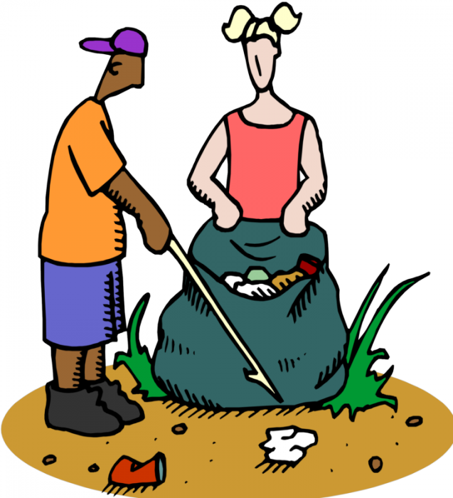

Please come along and join Bangor on Dee Community Councillors in a Community Litter Pick.

All litter picking equipment and bags will be supplied by Bangor on Dee Community Council.

For more information, please contact Bangor on Dee Community Council by email [bangorondeecc@gmail.com](mailto:bangorondeecc@gmail.com) or on 07907178340