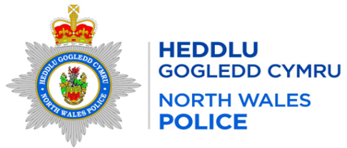

Local Report for the area of: WRW01 Bronington
Person Providing Report: PCSO 3464 Davies
Date of Report: 01/12/2025
Incidents of Note

Crime Reference Number | Date | Brief Circumstances
C176431 | 13/11/2025 | Dangerous Dogs – Neighbour attacked by dog - Bronington
C176276 | 13/11/2025 | Public Order – Intoxicated male - Worthenbury
C177541 | 15/11/2025 | Common Assault - Victim assaulted by named suspect - Whitchurch
C181200  C184921  C185265 | 22/11/202529/11/202529/11/2025 | Theft of poultry – Bangor-On-Dee  Theft of poultry – Bangor-On-Dee  Theft of poultry – Bangor-On-Dee
C176557 | 13/11/2025 | ASB – Suspicious male in church grounds - Worthenbury

Additional Information
What can you do to help – In order to progress matters and take positive action re drug dealing / ASB / Other crime trends etc we need community intelligence to support our targeted patrols, stop searches and warrants so please forward on any information that you are aware of/told within the community.

Any concerns about speeding in your community can be reported via the Go Safe website –
Report Speeding Concerns in your Community | GoSafe

Completed Activity
High visibility patrols have been carried out in the area

Feedback or Questions for Next Meeting

