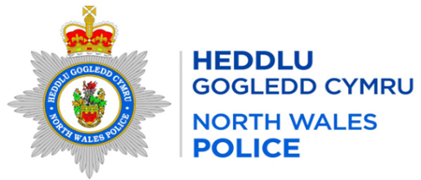

Local Report for the area of: WRW01 Bronington
Person Providing Report: PCSO 3464 Davies
Date of Report: 01/02/2026

Incidents of Note

Crime Reference Number | Date | Brief Circumstances
O004127 | 09/01/2026 | Quad bike & tools stolen - Worthenbury

Additional Information
What can you do to help – In order to progress matters and take positive action re drug dealing / ASB / Other crime trends etc we need community intelligence to support our targeted patrols, stop searches and warrants so please forward on any information that you are aware of/told within the community.

Any concerns about speeding in your community can be reported via the Go Safe website –
Report Speeding Concerns in your Community | GoSafe

Completed Activity
High visibility patrols have been carried out in the area

Feedback or Questions for Next Meeting

