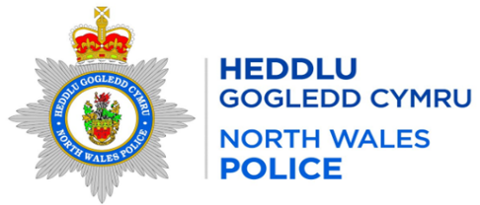
Local Report for the area of: WRW01 BRONINGTON
Person Providing Report: PCSO 3464 Davies
Date of Report: 11/05/2026

Incidents of Note
Crime Reference Number | Date | Brief Circumstances
O052677 | 07/04/2026 | Criminal Damage – Ongoing neighbourhood dispute – Worthenbury
O052677 | 09/04/2026 | Burglary Residential – Domestic related burglary – Whitchurch
O057491 | 16/04/2026 | Dangerous dogs – Dogs off lead approached victim – Whitchurch
O057851 | 17/04/2026 | Burglary – Victims vehicle stolen – Lower Wych
O057950 | 17/04/2026 | Burglary – Machinery Stolen – Eglwys Cross
O059782 | 20/04/2026 | Criminal Damage – Damage to victims fence - Tallarn Green

Additional Information
What can you do to help – In order to progress matters and take positive action re drug dealing / ASB / Other crime trends etc we need community intelligence to support our targeted patrols, stop searches and warrants so please forward on any information that you are aware of/told within the community.

Any concerns about speeding in your community can be reported via the Go Safe website –
Report Speeding Concerns in your Community | GoSafe

Completed Activity
High visibility patrols have been carried out in the area

Feedback or Questions for Next Meeting

