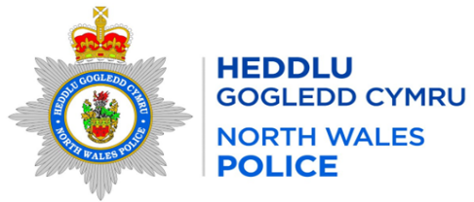
Local Report for the area of: WRW01 BRONINGTON
Person Providing Report: PCSO 3464 Davies
Date of Report: 05/06/2026

Incidents of Note
Crime Reference Number | Date | Brief Circumstances
O066371 | 01/05/2026 | Common Assault – Assault between youths in park – B-O-D
O067671 | 03/05/2026 | Criminal Damage – Domestic related - Tybroughton
O073302 | 13/05/2026 | Criminal Damage – Domestic related – Eglwys Cross
O076023 | 18/05/2026 | Theft – Theft of logs – B-O-D
O078251 | 22/05/2026 | ASB – Persons taking pictures on private property – Higher Wych
O079452 | 23/05/2026 | Common assault – Domestic related – B-O-D
O084322 | 31/05/2026 | Public order – Dispute over taxi fare – B-O-D

Additional Information
What can you do to help – In order to progress matters and take positive action re drug dealing / ASB / Other crime trends etc we need community intelligence to support our targeted patrols, stop searches and warrants so please forward on any information that you are aware of/told within the community.

Any concerns about speeding in your community can be reported via the Go Safe website –
Report Speeding Concerns in your Community | GoSafe

Completed Activity
High visibility patrols have been carried out in the area

Feedback or Questions for Next Meeting

